TECHNICAL PROJECT REPORT

# Title of Invention / Project: GESTURE BASED PRODUCT

# Team Members / Inventors:

|  |  |  |  |  |  |
| --- | --- | --- | --- | --- | --- |
| **S. No.** | **Name** | **Department** | **Designation** | **Mobile** | **E-Mail** |
| 1. | HRITHIK VATSAL | AIT | STUDENT | 8288985647 | hrithiksaxena854@gmail.com |
| 2. | MOHIT PANDEY | AIT | STUDENT | 9897389252 | pmohit605@gmail.com |
| 3. | RAMSHA AHAMAD | AIT | STUDENT | 7073399786 | ahamadramsha0192@gmail.com |
| 4. | DIVYANSHU GAUTAM | AIT | STUDENT | 9358293842 | divyanshugautam2015@gmail.com |
| 5. | Khushal Thakur | ECE | Mentor | 9646030764 | khushal.thakur@cumail.in |
| 6. | Anshul Sharma | ECE | Mentor | 9478697475 | anshulsharma.ece@cumail.in |
| 7. | Kiran Jot Singh | ECE | Mentor | 9463909689 | kiranjotsingh.ece@cumal.in |
| 8. | Divneet Singh Kapoor | ECE | Mentor | 9878422653 | divneet.ece@cumail.in |

***Section – 1 (IPR Related)***

# Brief Abstract :

1)*This project is very useful for the students as they won’t have to get up and turn the switch on and off to switch on or off their study lamp.

*This project is also useful for lygophobic persons (fear of darkness) as now they won’t have to hunt for switches in darkness the lamp would turn on detecting their motion.

2)Our product senses motion and turns on and off according to it.

3)We can provide battery backup to the project so that it never stops working.

# Existing state-of-the-art and Drawbacks in existing state-of-the-art

|  |  |  |
| --- | --- | --- |
| **S. No.** | **Existing state of art** | **Drawbacks in existing state of art** |
| 1 | Philips Plastic Hue Motion Sensor Lamp  MODEL : **464602** | *It can’t be operated from a distance and it is only functional for turning on the lamp one can’t wave his to switch it off.  *It is too expensive. |

# Novel/Additional modifications that you can propose to improve upon drawbacks

* It can’t be operated from a distance.

Advantages

Following are the advantages of motion sensor of active and passive types:

➨It can be used in very harse environment having irregular heat cycles (Active Motion Sensor).

➨It has more lifespan which is about 100000 Hrs (Active type).

➨It detects motion in light and dark conditions reliably in indoors. (Passive motion sensor)

➨It helps in providing security by detecting suspicious movement.

➨It is easy to install motion sensors.

Disadvantages of motion sensor

Following are the disadvantages of motion sensor of active and passive types:

➨Radio frequency at high power is harmful for humans (active type).

➨Radio frequency in microwave range do not penetrate metal objects (active type).

➨Passive motion sensors do not operate above temperature of 350C.

➨Passive sensor type works in LOS (Line of Sight) and does not work in non-LOS regions.

➨Passive type is insensitive to very slow motion of the object.

➨Passive Infrared (PIR) Sensor can detect human being within approx. 10 meters range.

➨Any kind of moving object can trigger the PIR sensor type.

# Block Diagram

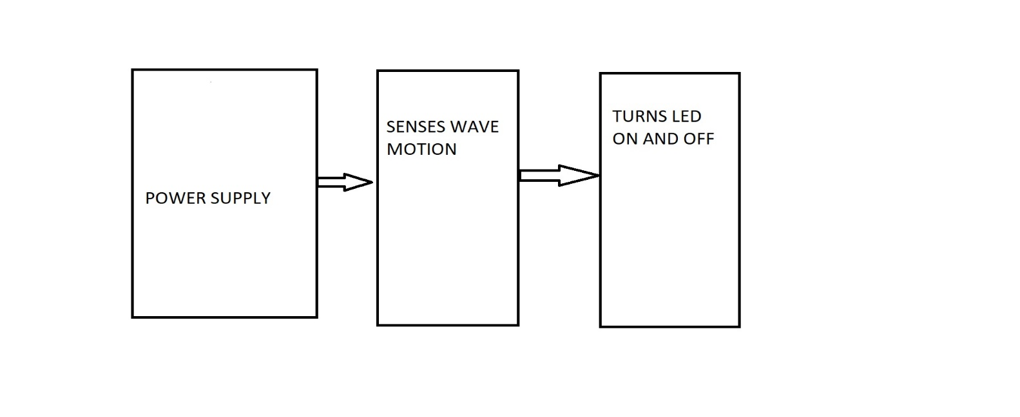

***Section – 2 (Real Project)***

# Materials

*Breadboard-1

*Jump wires-9

*Resistor-4.7ohms-1

*Resistor-150ohms-1

*LEDS-3

*PIR SENSOR-1

CIRCUIT DIAGRAM :

# C:\Users\asus\Desktop\WhatsApp Image 2018-11-17 at 11.02.32.jpeg

# Steps of Circuit Completion

1)Connect PIR Sensor to the breadboard .

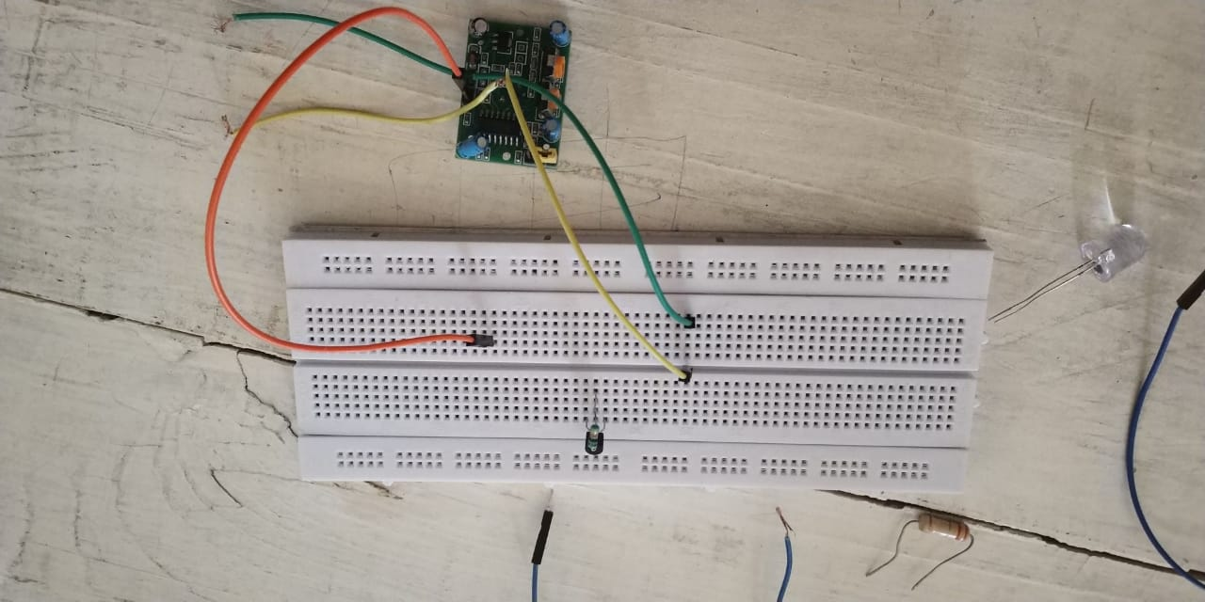

2) Connect LEDS to the breadboard .

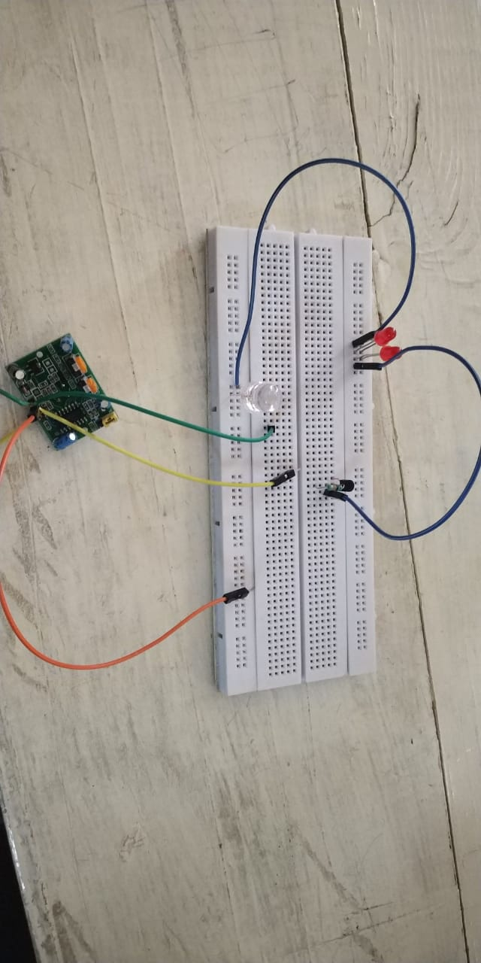

3) COMPLETE CIRCUIT.

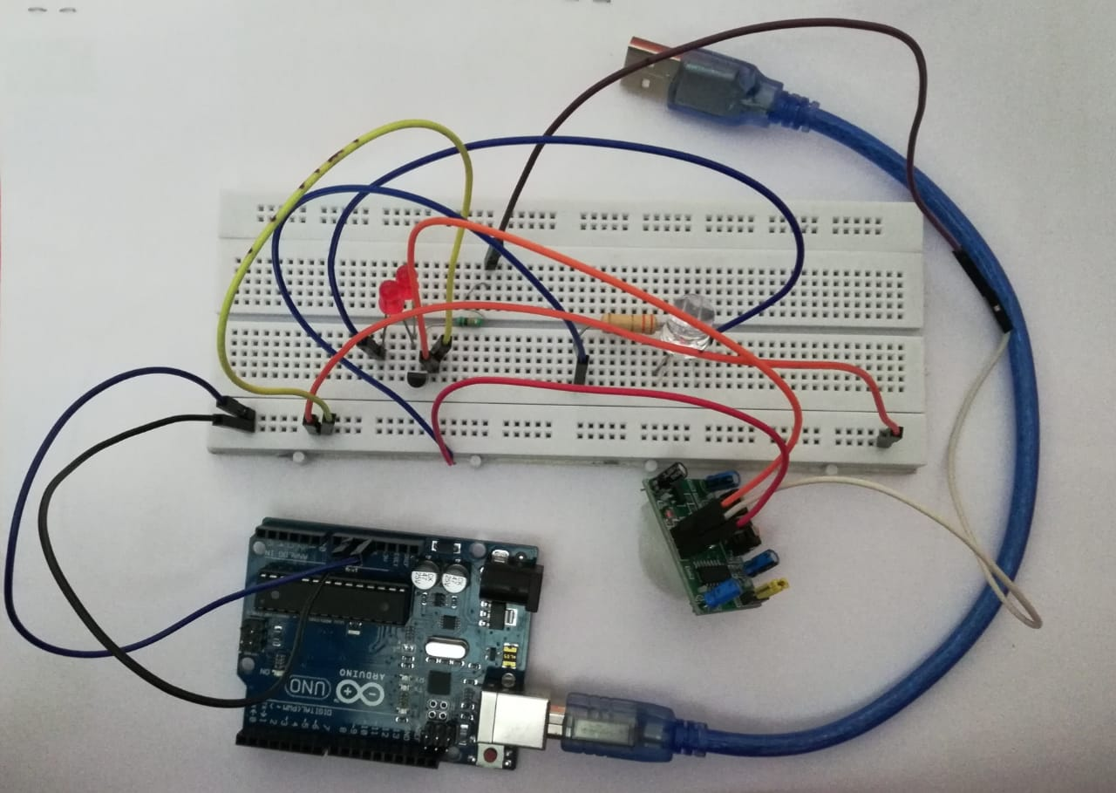

Program Code

https://github.com/hrithiksaxena854/DEKSTOP/blob/master/BEEEPROJECT.ino